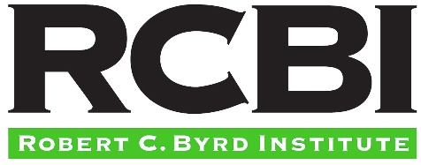

FOR IMMEDIATE RELEASE Contact: Mike Friel
May 15, 2018 304.781.1686

SBIR Road Tour rolls into Huntington June 21
Small business owners can meet with federal agencies,
learn about $2.5-plus billion in funding opportunities
The U.S. Small Business Administration’s (SBA) National SBIR Road Tour is coming to Huntington on June 21, giving small business owners and researchers the opportunity to learn firsthand about America’s largest federal seed fund that awards more than $2.5 billion annually.
Through the Small Business Innovation Research (SBIR) and Small Business Technology Transfer (STTR) programs, the federal government awards funding to assist small businesses in development of groundbreaking, high-risk technologies while taking no equity.
The SBIR Road Tour plays an important role in increasing engagement with entrepreneurial ecosystems across the country and building a greater network to support the creation of small businesses focusing on high-impact research. The SBIR Road Tour also advances goals of the SBIR/STTR programs, including outreach to increase the participation by women, individuals who are socially and economically disadvantaged, as well as small business owners who reside in underrepresented states.
Hosted by Marshall University, the Robert C. Byrd Institute (RCBI), the Marshall University Research Corporation, the Alliance for the Economic Development of Southern West Virginia and the West Virginia Small Business Development Center, the Huntington stop focuses support on entrepreneurs in next-generation research and development.
Program managers from at least 12 federal agencies will conduct one-on-one meetings with attendees, participate in targeted panel discussions, and share insights into how their agencies make funding decisions. Funding a wide variety of technology areas, the SBIR/STTR program supports unmanned systems, advanced materials, health, cyber security, defense and others.
The SBIR/STTR programs provide more than 4,000 new awards each year. These awards have helped U.S. innovators advance new technologies and contributed to the creation of thousands of jobs.
Small technology firms, innovators, scientists or researchers seeking more information on the SBIR Road Tour should visit www.sbirroadtour.com. Register for the June 21 Huntington event, which is scheduled at Marshall University’s Weisberg Family Applied Engineering Complex, at www.rcbi.org/go/sbir.
For more information, contact RCBI’s Bill Woodrum at bwoodrum@rcbi.org or 304.781.1670.
###

