DAY OF INNOVATION

The National Park Service (NPS) and the William Paterson University of New Jersey (WPU) partnered for the purpose of connecting students from Paterson, NJ and West Orange, NJ to highlight Alexander Hamilton and Thomas Edison’s entrepreneurial spirit, making it relevant for today’s youth through the leadership of both the NPS and WPU’s SMALL BUSINESS DEVELOPMENT CENTER.
The “Day of Innovation” was a pilot project between William Paterson University Small Business Development Center (SBDC), and Paterson Great Falls National Historic Park and Thomas Edison NHP. The project helped connect students of both the Paterson and the West Orange areas of New Jersey to two near-by national park units. The areas are two of the most densely populated sections of the most densely populated state in the United States of America. The high school portion of the project continued over several months at John F. Kennedy High School in Paterson, NJ. Paterson, an 8-square mile city of some 160,000 people, is comprised of an estimated 52 separate ethnic/racial minorities of mostly Latino, African-American, and Arab populations. The project was designed to demonstrate that the new immigrant experience is in many ways similar to the experiences of those who helped grow their cities. The “Day of Innovation” event promoted entrepreneurial literacy through in-class lessons where the participants learned entrepreneurial and inventive skills and practices. With this newly gained understanding of best business and invention practices, high school students participated in a business plan competition (“Day of Innovation”) where student ideas were judged and feedback provided. The hope is that these young inventors will be inspired to take their ideas further to better help their community and their national parks.
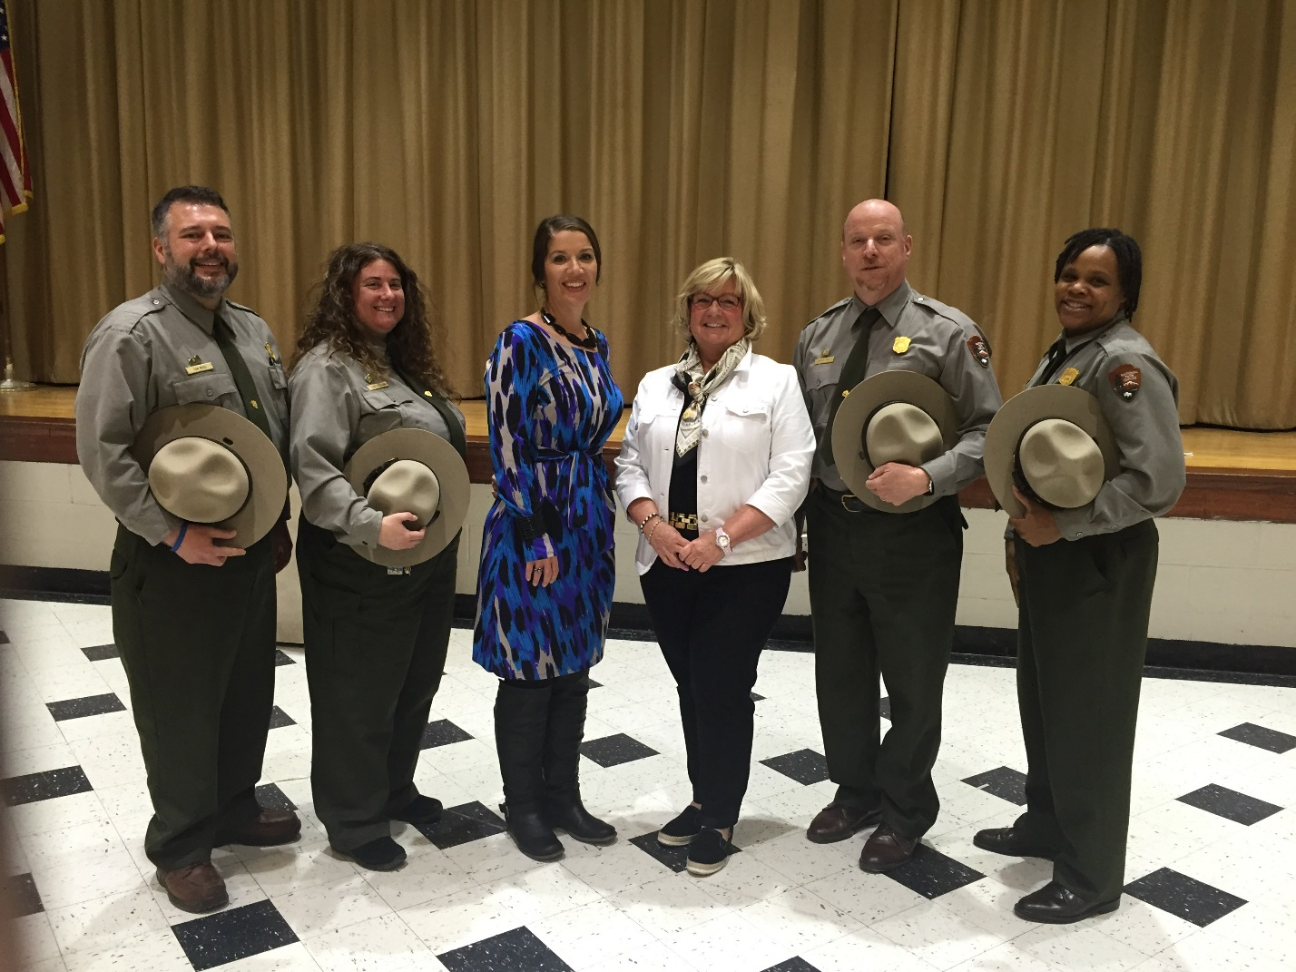
Pictured are the judges at the preliminary round of the “Day of Innovation”:
Tom Ross, Superintendent of Thomas Edison and Morristown National Historical Parks in New Jersey. Ilyse Goldman, Supervisory Park Ranger, Paterson Great Falls National Historical Park; Ms. Mary Howard Business Department Supervisor/Chairperson, John F. Kennedy High School; Kate Muldoon, Regional Director, William Paterson University SBDC; Darren Boch, Superintendent , Paterson Great Falls NHP; Shemaine McKelvin, Park Ranger, Thomas Edison National Historical Park.

